**Worksheet 2.2.2**

**Student Name: Devansh Pandey UID: 21MCA2604**

**Branch: MCA Section/Group MCA5-B**

**Semester: 4 DateofPerformance: 04-04-2023**

**Subject Name: Embedded Programming Subject Code: 21CAH-752**

**1. Aim/Overview of the practical: (For EVEN UIDs)**

Interface an Arduino Uno with Gas Sensor and seven segments to calculate the concentration of gas and print on a Serial monitor.

1. If the gas concentration is > 550 print F on seven segments.
2. If the gas concentration is < 550 and gas concentration is> 300 print E on seven segment display
3. If the distance is < 300 turn on the green light and 0 display on seven segment display.

**Note:**

1. **Paste the Screenshots of Every Circuit as per the mentioned case.**
2. **Screenshot should have your Name and UID (21MCI1234_XYZ)**
3. **Mention the comments in the programming.**

**2. Apparatus (For applied/experimental sciences/materials based labs):**

**Hardware Requirements**

**Software requirements**

**3. Circuit Diagram(TinkerCad):**

1. **Coding:**

#include <LiquidCrystal.h>

#define Smoke_sensor A0

#define Buzzer 10

#define green 7

#define yellow 6

LiquidCrystal lcd = LiquidCrystal(12,11,5,4,3,2);

void setup()

{

pinMode(Smoke_sensor, INPUT); // smoke sensor getting input through analog pin A0

pinMode(Buzzer, OUTPUT); // Buzzer output is coming from pin 10

pinMode(green, OUTPUT);

pinMode(yellow, OUTPUT);

lcd.begin(16, 2); // Set up the number of columns and rows on the LCD.

Serial.begin(9600);

// Print a message to the LCD.

lcd.setCursor(0, 0);

lcd.print("Smoke value is");

}

void loop()

{

float smoke_val= analogRead(Smoke_sensor); // converting value of smoke sensor to float value

Serial.print("Smoke value is :");

if(smoke_val>550){ // if value of smoke sensor is greater than 550

digitalWrite(green, HIGH); // then green light will in ON condition

digitalWrite(yellow, LOW);

lcd.setCursor(0, 1);

lcd.print(smoke_val);

Serial.println(smoke_val);

delay(1000);

}

else if(smoke_val>300 && smoke_val<550){

digitalWrite(yellow, HIGH); // if value of smoke sensor is greater than 300 and

digitalWrite(green, LOW); // less than 550 then yellow light will in on condition

lcd.setCursor(0, 1); // and red light will remains in off condition

lcd.print(smoke_val);

Serial.println(smoke_val);

delay(1000);

}

else{

digitalWrite(yellow, LOW); // if value of smoke sensor is less than 300

digitalWrite(green, LOW); // then both lights will remains in off condition

tone(Buzzer, 220, 100); // only buzzer will produce sound

lcd.setCursor(0, 1);

lcd.print(smoke_val);

Serial.println(smoke_val);

delay(1000);

}

}

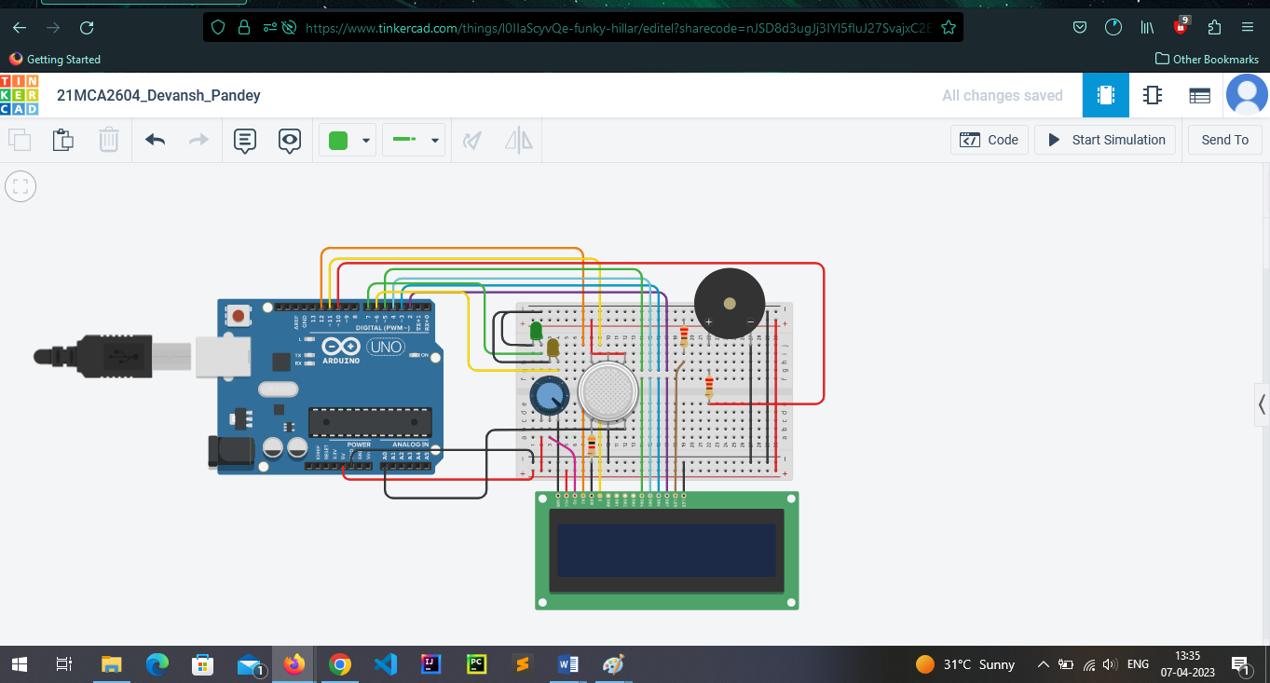

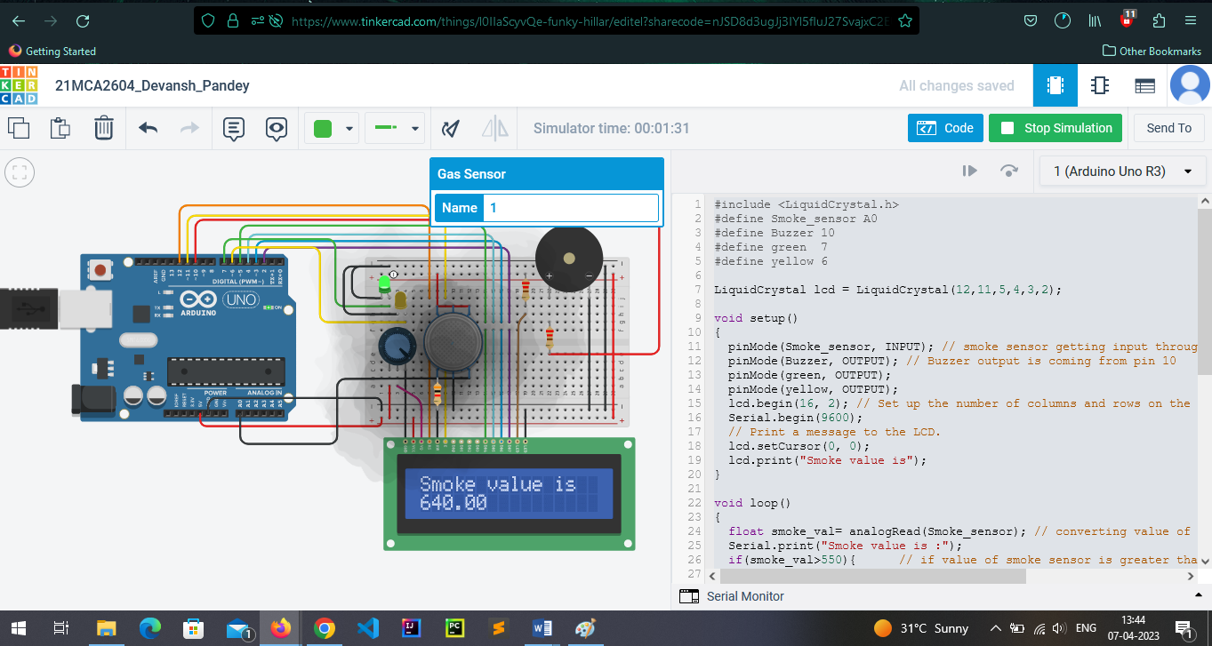

**5. Learning outcomes (What I have learnt):**

**1.**

**2.**

**3.**

**4.**

**5.**

**Evaluation Grid (To be created as per the SOP and Assessment guidelines by the faculty):**

|  |  |  |  |
| --- | --- | --- | --- |
| Sr. No. | Parameters | Marks Obtained | Maximum Marks |
| 1. | Worksheet Completion |  | 10 marks |
| 2. | Post Lab Quiz Result |  | 5 marks |
| 3. | Student Engagement  (Simulation/ Demonstrate/Performance and Pre-Lab Questions)) |  | 5 marks |
|  | Total |  | 20 marks |